D424 – Software Engineering
Task 3
Capstone Proposal Project Name: |   Loofi – Casual Game Arcade
Student Name: | Xandria Crosland

Table of Contents
Create a professional looking Table of contents that includes your main and subheadings and the related page numbers. Use the automatic TOC generating function of Word or other word processing packages to make the process easier.
The headings that follow are only examples of what might be included. You will need to create headings that are appropriate for your application and process.
Remember that this needs to be a professionally formatted document with detailed information about your project that is easily accessible.

Application Design and Testing

Class Design

The provided class diagram outlines the various entities, attributes and relationships created to develop the Loofi MVP. The platform utilizes a Spring application for the backend and a React application for the frontend, allowing for modularity and easy integration with MySQL for storage. The diagram primarily illustrates the structure of the Spring application and database schema and is implemented through Java classes and Lombok annotations.

Loofi is a platform that allows users to play casual games within the browser and connect with other users. The Spring application uses the JWT (JSON Web Token) package to provide robust security features for each user through the UserDetails entity. Serving as the basis for every account, the User entity implements the UserDetails entity and includes several attributes and methods required for each user. Additionally, the Admin class extends the User class and provides additional privileges for users with the “admin” role.
Further exploration of the User entity reveals additional relationships that affect the structure of the application and database schema. Firstly, each User has a role attribute which is an enumeration of either “ROLE_USER” or “ROLE_ADMIN”. Secondly, the User entity forms a many-to-many relationship with itself and represents the list of friends each user has. Ultimately, Java and Spring’s object-oriented programming approach provides an efficient solution for developing a platform that is scalable and modular which can be identified through the relationships and methods among these entities.
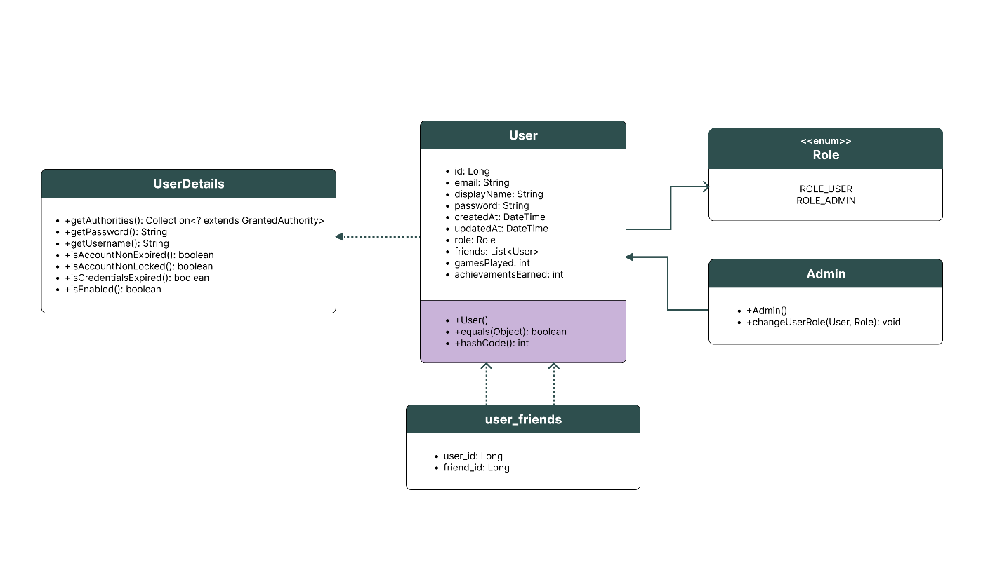
Figure 1: Loofi’s UML Class Diagram

UI Design
Loofi prioritizes seamless user-centered design to bolster its mission of providing casual, fun and accessible gaming experiences. This is reflected through the low-fidelity wireframes and prototype serving as the MVP. The following graphics showcase the initial design for the core pages of the application, with the last image containing an additional page that was added during the development of the prototype.
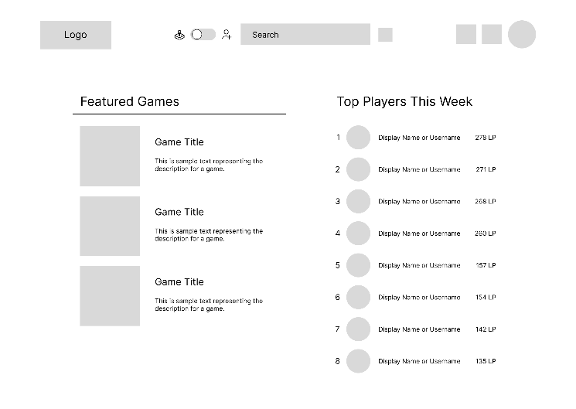
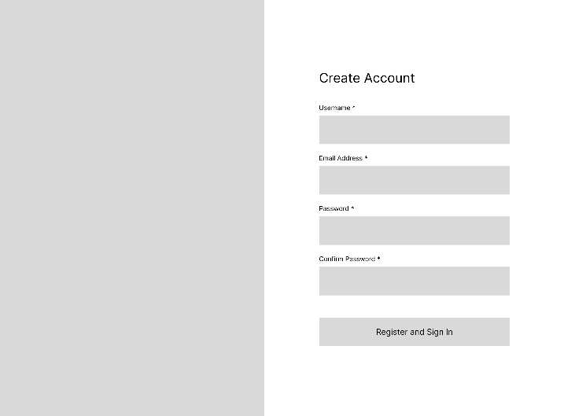
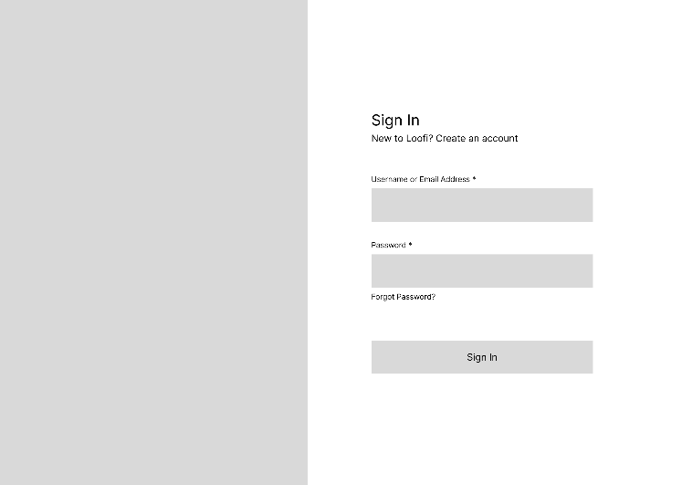
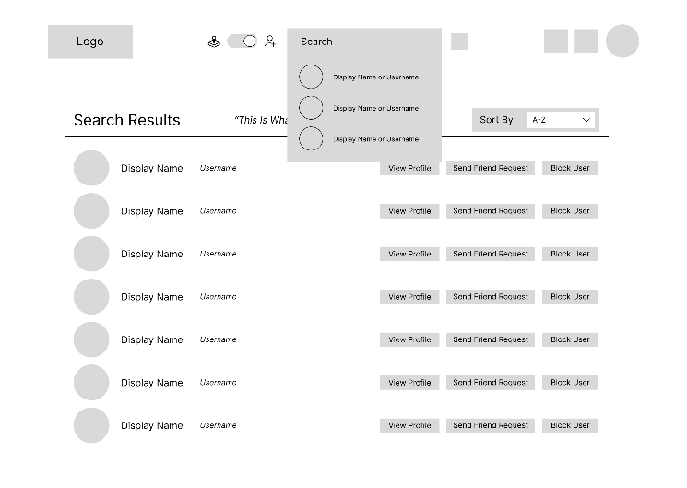
When the user navigates to the Loofi website they are prompted to either sign in to their existing account or sign up for an account (Figure 2 and 3). After successful login or account creation, the user is taken to the home page of the application (Figure 4) which includes a navigation bar, selections from the game library, and a leaderboard. The navigation bar (Figure 5) contains the search bar that allows users to look up other users followed by various options such as adding them as a friend. If a user chooses a selection from the game gallery, they will be taken to a page that includes a description of the game, recommended games, and a leaderboard (Figure 6). These pages bolster the user experience by providing familiar capabilities through efficient layouts, allowing users to spend more time gaming than figuring their way around the platform.
Figure 4: Home Page
Figure 3: Sign-Up Page
Figure 1: Sign-In Page
Figure 5: User Search Results Page

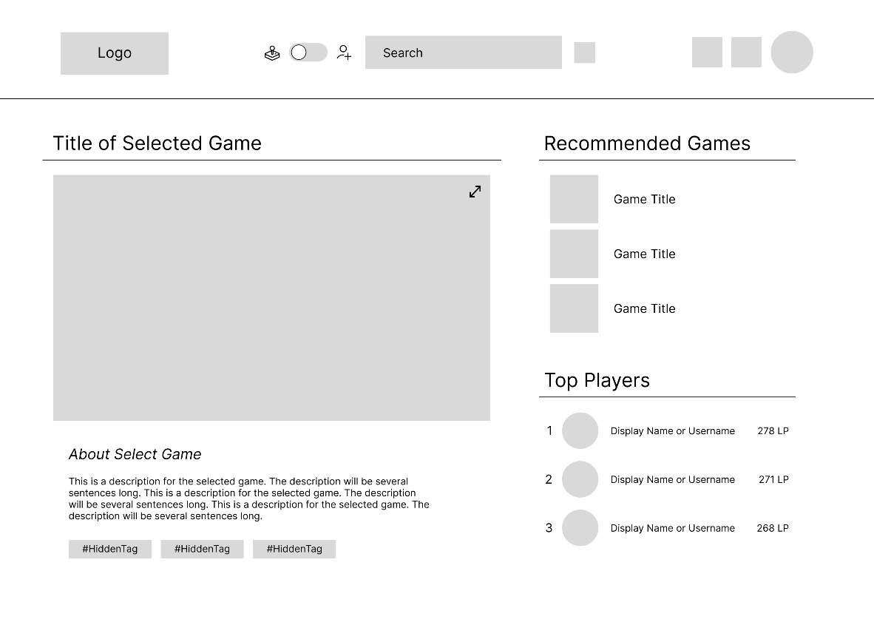
Figure 6: Selected Game Page
Users can manage various account settings and view additional information by navigating to their dashboard. Users with administrative privileges are given additional features, thus providing a slightly different application design to the user. The default page of the user dashboard is the profile editor (Figure 7), but users can navigate to other pages in the dashboard using the side menu. If a user needs to change their email or password, or permanently delete their account, they can do so from the account settings page (Figure 8). In addition, users can view a list of their friends on the friend network page (Figure 9) with the option to remove users at any time. A user with elevated privileges has the added ability of toggling other users’ role between user and admin. Finally, admins gain an additional dashboard page that holds reports on the platform’s analytics (Figure 10), such as user accounts and statistics. The account dashboard offers a range of robust features that allow users to manage their information and connections with other users, contributing to a premier online gaming experience.
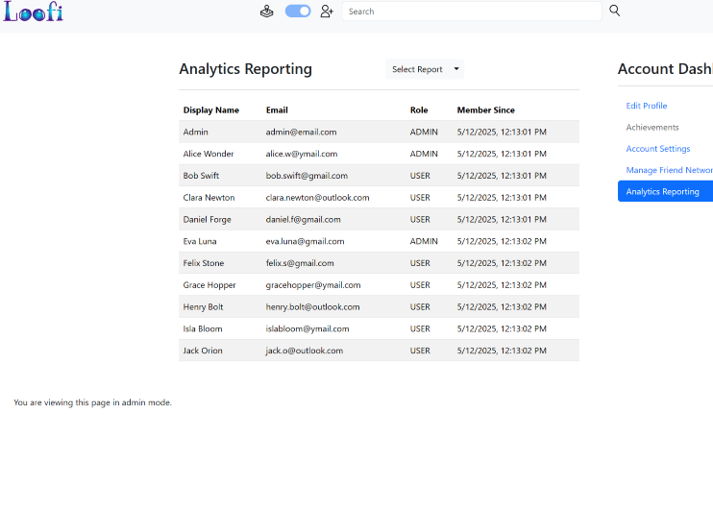
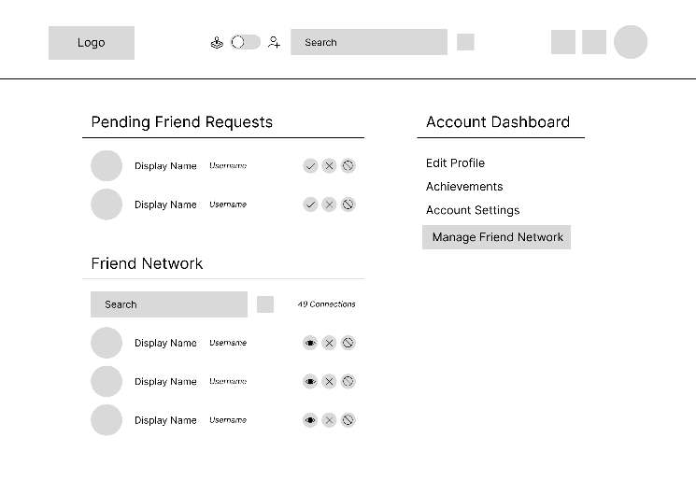
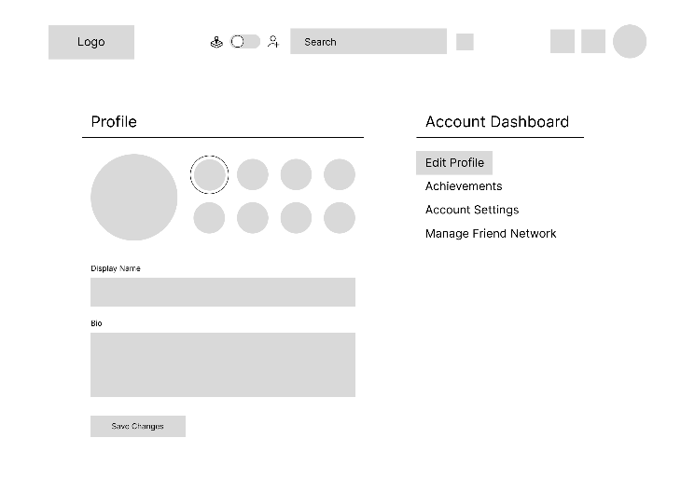


Figure 9: Account Dashboard Page – Friend Network

Figure 10: Account Dashboard Page – Analytics Reporting

Figure 7: Account Dashboard Page – Edit Profile

Figure 8: Account Dashboard Page – Account Settings

Unit Test Plan

Introduction

Purpose
Provide a brief description of the testing method(s) that you used and what the results it yielded. Also, what remediation was required if necessary and how it would be performed.

Overview
Here you go into more detail about the test(s) and how it related to the overall project. You should include if a similar method was used in other parts of the application or why this was unique for a certain aspect of the code. Then, go into detail about what functions were tested, how the tests were conducted, and how errors were dealt with.

Test Plan

Items
- Source Code: The git repository includes the automated test scripts and docker compose file for handling database setup and executing test scripts.
- Local Development Environment: An IDE, such as IntelliJ, must be installed in the case of debugging and test script development. Docker is also needed to start and stop containers.
- Test Framework: The commonly used JUnit framework combined with Spring’s test framework MockMvc for testing REST API endpoints.

Features
- User Authentication: Test user login and sign-up requests, as well as authorization token needed to access the application.
- Account Management: Test ability to change emails or passwords, and permanently delete accounts.

Deliverables
- Test Scripts: The tests folder contains files the house the scripts to be executed using JUnit and Spring MockMvc for integration testing.
- Result Table: A final diagram that describes the test executed, whether it passed or fail, and any notes on the next steps to be taken.

Tasks
- Install an IDE, such as IntelliJ, and ensure the source code contains the necessary packages and frameworks for testing (Spring Test MockMvc, JUnit, Docker).
- Ensure the source code includes the test scripts and a Dockerfile.test configured to run these scripts during container execution.
- Start the Docker containers defined in the Docker Compose file, which will start the MySQL database container and the Spring Boot container. The MySQL database is populated with seed data by a Spring-managed component at runtime.
- Review the test results to identify any failed tests or errors. Passed JUnit tests should will log standard output to the console, while failures or errors result in a non-zero exit code for the container.

Needs
- Software Requirements: While docker containers allow the application to be run without local installation of Java 17+, Node.js, or MySQL, installing them ensures the application can be tested and database changes can be monitored.
- Frameworks and Packages: The latest version of JUnit compatible with Spring version 3.4.4 and MockMvc are required to execute the test scripts. This can be configured in the pom.xml file within the Spring application.
- Spring Application Source Code: The source code includes the automated test scripts and the spring application must be running during testing in order to set up and connect to the database. Access also allows test scripts or other aspects of the code to be altered and managed via git.

Pass/Fail Criteria
The following table outlines each of the features tested and the determining factor of a successful and unsuccessful test. In the event of a failed test the issue must be remediated and documented for further investigation and debugging. The root cause of the issue must be identified by reviewing the messages logged to the IDE’s console or terminal and locating the relevant files. Once the cause of the issue is found, a report must be drafted that includes the failed test script name, the severity of the bug found, associated error messages, steps to replicate the issue, and additional information necessary for resolution.
Feature | Pass | Fail
User Sign In | The user is authenticated with a valid email and password, and receives an authentication token. | The user is not found or authenticated, and no authentication token is administered.
User Sign Up | The user is added to the database and receives an authentication token. | The user is not added to the database and an authentication token is not received.
Email Change | The user provides a valid email address and receives confirmation of the email change. | The user could not be found or provides the current email address of the account.
Password Change | The user provides a valid password and receives confirmation of the password change. | The user could not be found or provides the current password of the account.
Account Deletion | The account is deleted from the database. | The account is not deleted from the database.

Specifications
Provide sample code that represents what testing code was used. Screenshots are acceptable.
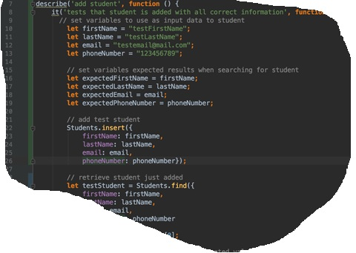

Procedures
- Create Test Plan: Outlined the items needed, features to be tested, final deliverables, and pass/fail criteria to be used throughout testing phase.
- Setup Development Environment: Installed the necessary dependencies and frameworks. Verified the correct version and configuration of tools and technologies. Created a test-specific Dockerfile and configured the Docker Compose file, enabling test scripts to run in a containerized environment.
- Write Test Scripts: Created files containing the various test scripts to be executed automatically when containers are run.
- Run Tests: Built and ran the containers with docker-compose, which executed the test scripts automatically via the configured Dockerfile. Alternatively, tests can be executed manually inside the container using mvn test if needed.
- Review and Document Results: Analyze the test results to identify any failed tests. Revise test plan and source code as needed to address issues identified. Draft a report based on the test results that includes the outcome of each test, any identified issues, and iterations made to the test plan or source code, and further improvements to be made.

Results
Here you will describe and provide examples of the testing results. If you were using a testing package include a screenshot of the interface. Screenshot work best.
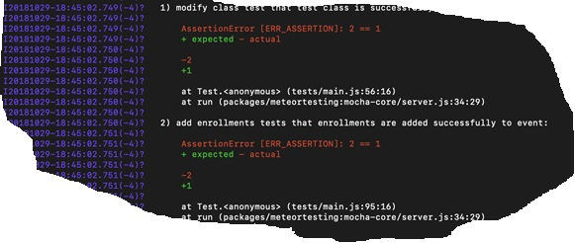

Hosted App and Remote Repository
Link to hosted application:
Link to GitLab Repository:


Figure ##: GitLab Branch History

User Guide for Maintenance

Introduction
The following guide provides an overview of the various prerequisites and steps required to setup, run, and deploy maintenance updates to the Loofi application.
Pre-requisites
- Java 17+
- Node Package Manager and Node.js
- MySQL Workbench and MySQL Server
- Git
- An Azure account
- Docker Desktop Client
- GitLab repository link
Local Development Setup
- Example
Initial Deployment
- Example
Subsequent Deployments

C5. User guide for running the application from a user perspective
User Guide for Users

Introduction
Provide a description of the content you’re providing in the User Guide. This guide will include how to install, log into, sign up, and use all of the functions of the application. The steps need to be clearly defined and fully tested so the process works flawlessly for the evaluator.

Installation and Using the Application
This procedural information should follow the basic rules of such technical references. While some procedures may provide for personal judgment yours should be clear and concise. Here are other rules to remember:
- Provide step-by-step sequences in the correct order.
- Follow the timing and sequencing of the actual operations.
- Provide visual stepping stones by using bullets or labeling steps.
- Strive to be concise. Avoid lengthy paragraphs but include enough detail so false assumptions are not made.
- Use common terms and jargon appropriate for the audience (someone with basic IT background).
- Explain why steps are completed or what they will yield as well as "How to" instructions.
- Test the instructions to ensure they match the actual product.
- Format the material for ease of reading and use graphic aids to clarify point/steps.
- Write in the present tense and the active voice.

Login and Signup (An example)
- Click the "Log in" button in the top right corner of the app.
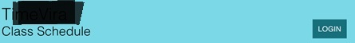
- If you already have an account, log in with your account name and password. If you need an account, click on the link below that states “Need an account?”
- If you need to create an account, choose a unique username and password. By default, the password requires at least 6 characters. This function could be changed to address new password requirements.

Classes

Create a New Class
- Once logged in, click on the link at the top labeled “Classes”. This will enable you to create a new class of students.

- Click on “+ Add Class”.
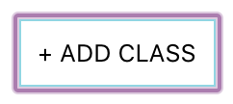
- Enter a class name and its description. The class name must be unique.
- Click “Add Class” to add the class, otherwise click “Cancel” or outside of the modal to cancel adding the class.
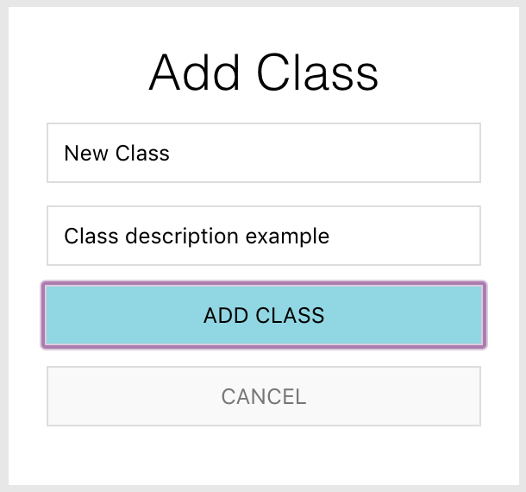

Reports
- To access the reporting feature, from the Schedule module, click on “Generate Report” near the top right of the page.
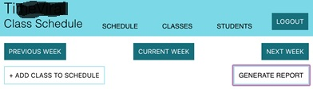
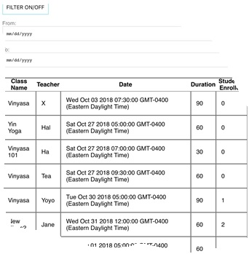
- By default, all events are generated and displayed.

